1. Grade Checker
Take a score as input and print the grade based on the following:
90+ : "A" 80-89 : "B" 70-79 : "C" 60-69 : "D"Below 60 : "F"
here we used a basic if else statement to carry out marks and all.
marks= int (input("Enter your score:"))
if marks>= 90:
Grade= "A"
elif marks>=80:
Grade= "B"
elif marks>=70:
Grade= "C"
elif marks>=60:
Grade= "D"
else:
Grade= "F"

print("Your Grade is : ", Grade)
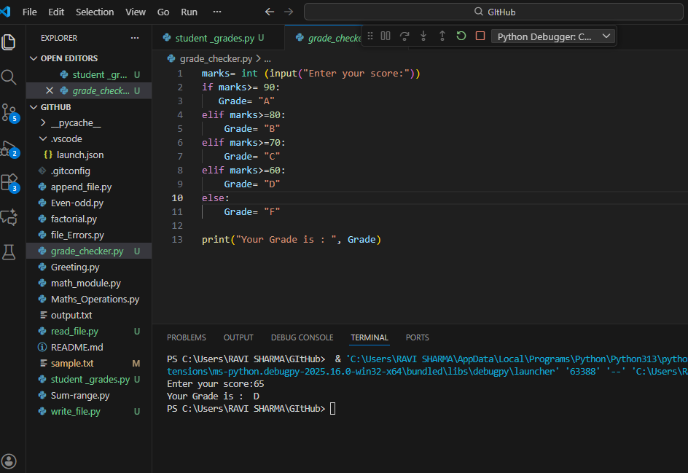

2 Student Grades
Create a dictionary where the keys are student names and the values are their grades. Allow the user to:
Add a new student and grade.
Update an existing student’s grade.
Print all student grades. Used dictionary and basic operations. Using if else:
students = {}
while True:
print("\n--- Student Grades Manager ---")
print("1. Add new student and grade")
print("2. Update existing student’s grade")
print("3. Print all student grades")
print("4. Remove existing student’s")
print("5. Exit")

choice = input("Enter your choice (1-5): ")
if choice == "1":
name = input("Enter student name: ")
grade = input("Enter grade: ")

if name in students:
print("Student already exists!")
else:
students[name] = grade
print("Student added successfully.")

elif choice == "2":
name = input("Enter student name to update: ")

if name in students:
grade = input("Enter new grade: ")
students[name] = grade
print("Grade updated successfully.")
else:
print("Student not found!")

elif choice == "3":
if not students:
print("No students found.")
else:
print("\n--- Student Grades ---")
for name, grade in students.items():
print(f"{name}: {grade}")

elif choice == "4":
name = input("Enter student name to update: ")

if name in students:
del students[name]

print(" Remove successfully.")
else:
print("Student not found!")

elif choice == "5":
print("Exiting program...")
break

else:
print("Invalid choice! Please try again.")

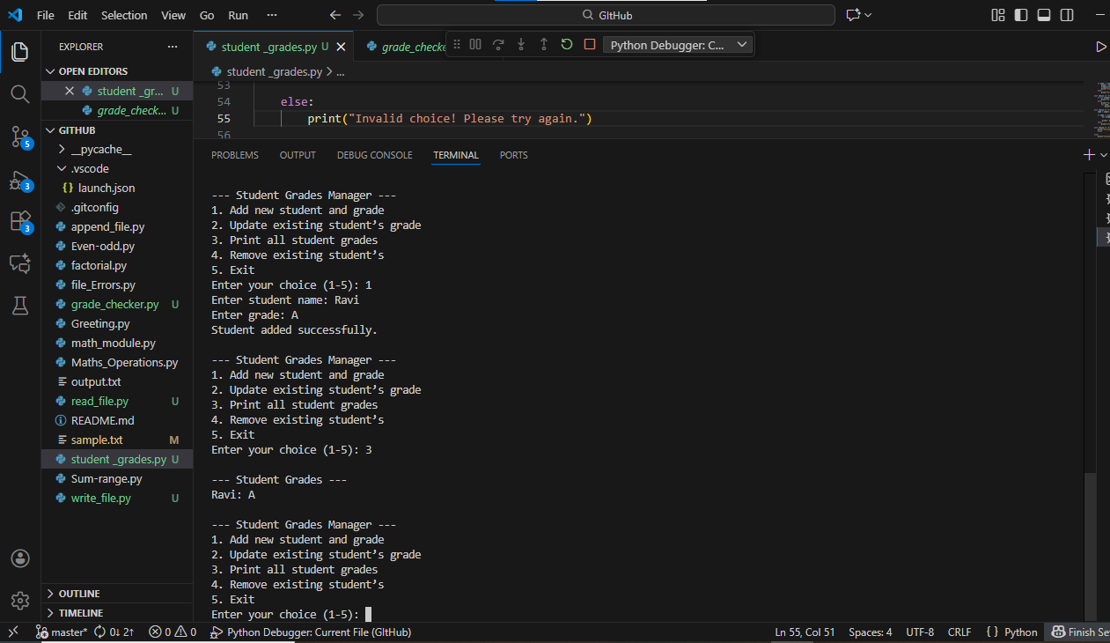

3.Write to a File
Write a program to create a text file and write some content to it.Using file functions like write and open.
f=open('sample.txt','r+')

data=f.read()

print(data)

f.write("\n My Name is Ravi kumar sharma.")

f.close()
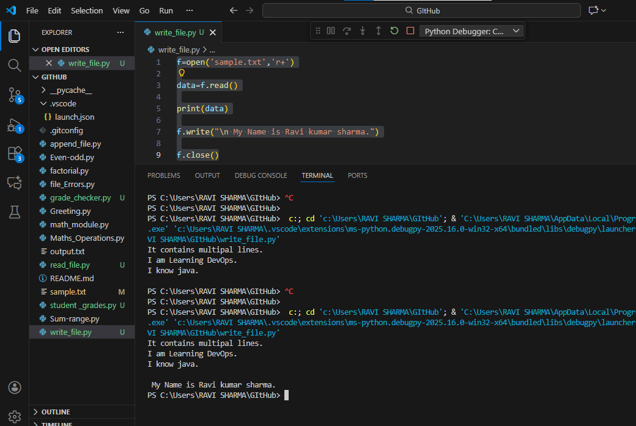

4. Read from a File
We used open in read mode and file.read to read and print to display.
f=open('sample.txt','r')

data=f.read()
print(data)

f.close()
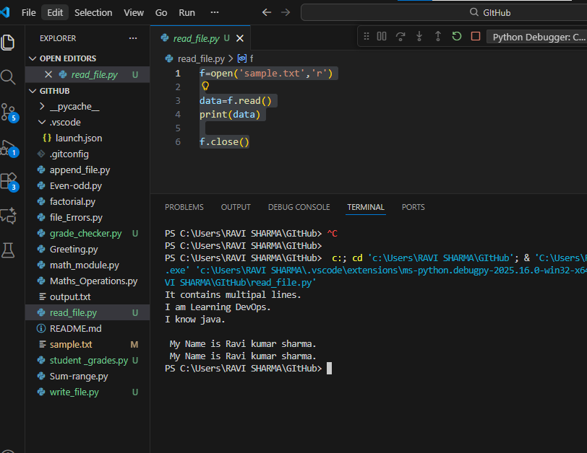

GitHub:
https://github.com/ravisharma2191/DevOps

